Year 10 · Cambridge IGCSE

NAME

CLASS |  |  | DATE

COMPUTER SCIENCE 0478
Papers 1 and 2
Revision Paper · MARK SCHEME about 2 hours 15 minutes
Teacher copy: answers in red, marking points after each question.

INSTRUCTIONS
- Answer all questions.
- Show all your working for conversions and binary calculations.
- Use a pencil for diagrams, flowcharts and lines.
- Calculators must not be used.

INFORMATION
- The total mark is 114.
- The number of marks for each question or part question is shown in brackets [ ].
- Section A: Chapter 1 Data representation and Chapter 2 Data transmission (Questions 1–8).
- Section B: Chapter 7 Algorithm design and problem-solving (Questions 9–15).

For teacher use
Question | 1 | 2 | 3 | 4 | 5 | 6 | 7 | 8 | A
Marks | 11 | 10 | 10 | 6 | 10 | 4 | 6 | 12 | 69
Score

Question | 9 | 10 | 11 | 12 | 13 | 14 | 15 | B | Total
Marks | 4 | 3 | 4 | 10 | 8 | 10 | 6 | 45 | 114
Score

Section A
Chapter 1 Data representation · Chapter 2 Data transmission
1 Binary is a number system used by computers.
Source: 0478/11 May/June 2023 Q1
(a) Tick (✓) one box to show which statement about the binary number system is correct.
A | It is a base 1 system
B | It is a base 2 system | ✓
C | It is a base 10 system
D | It is a base 16 system

[1]
(b) Denary numbers are converted to binary numbers to be processed by a computer.
Convert these three denary numbers to 8-bit binary numbers.
50
102
221 [3]
Working space

(c) Binary numbers are stored in registers. Negative denary numbers can be represented as binary using two’s complement.
Complete the binary register for the denary number –78. You must show all your working.
Working space

Register: [2]
1 | 0 | 1 | 1 | 0 | 0 | 1 | 0

(d) Two 8-bit binary numbers are given. Add the two 8-bit binary numbers using binary addition. Give your answer in binary. Show all your working.
+  c | 0  0  1  1 | 0  1  0  1 | 1  1  0 | 1  0  1 | 0  0  0 | 0  0  1  1 | 1  0  0  1 | 1  1  0

[3]
(e) Two binary numbers are added by a computer and an overflow error occurs. Explain why the overflow error occurred.

[2]
Marking points
(a) B [1]
(b) 00110010 · 01100110 · 11011101 (one mark each) [3]
(c) 1 mark full working (e.g. 78 = 01001110, flip bits, add 1) · 1 mark answer 10110010 [2]
(d) 1 mark each correct nibble: 1001 0100 · 1 mark correct working showing the carries [3]
(e) Two from: the result is greater than 255 // larger than can be stored in the register · the result needs more than 8 bits // the register has a fixed number of bits and there are too many bits [2]
2 Binary numbers can be converted to hexadecimal.
Source: 0478/12 May/June 2023 Q2
(a) Convert the two binary numbers to hexadecimal.
10010011
00001101 [4]
Working space

(b) A value is stored as a binary number in a register.
0 | 1 | 1 | 1 | 1 | 0 | 1 | 0

A logical right shift of three places is performed on the binary number.
(i) Complete the binary register to show its contents after this logical right shift.
0 | 0 | 0 | 0 | 1 | 1 | 1 | 1

[1]
(ii) State one effect this logical shift has on the binary number.
[1]
(c) Give two reasons why a programmer may use hexadecimal to represent binary numbers.
1
2 [2]
(d) Denary numbers can also be converted to hexadecimal. Convert the denary number to hexadecimal.
301 [2]
Working space

Marking points
(a) 93 · 0D (one mark per correct character in the correct order) [4]
(b)(i) 00001111 [1]
(b)(ii) Any one: the value becomes incorrect / inaccurate as the right-most bits are lost // it is divided by 8 [1]
(c) Any two: easier / quicker to understand / read / write · easier / quicker to debug · less likely to make a mistake · shorter representation // takes up less screen space [2]
(d) 12D (1 mark for two correct characters, 2 marks for all three in order) [2]
3 When keys are pressed on a keyboard, the text is converted to binary to be processed by the computer.
Source: 0478/12 May/June 2023 Q3
(a) Describe how the text is converted to binary to be processed by the computer.

[3]
(b) Text that is input into a computer can be stored in a text file. A text file can be compressed using lossless compression.
(i) State what effect this has on the file size.
[1]
(ii) Describe how lossless compression compresses the text file.

[4]
(iii) Give two reasons why the text file may have been compressed.
1
2 [2]
Marking points
(a) Any three: a character set is used · … such as Unicode / ASCII · each character has a unique binary value [3]
(b)(i) It reduces the file size [1]
(b)(ii) Any four: a compression algorithm is used · … such as RLE / run-length encoding · repeating words / characters / phrases / patterns are identified · … and indexed · … with the number of occurrences · … with their position [4]
(b)(iii) Any two: to save storage space · to make it quicker to transmit · to make it small enough to attach to an email · to reduce the bandwidth needed to transmit [2]
4 A photographer takes an image with a digital camera. The photographer sets the resolution and colour depth for the image.
Source: 0478/13 October/November 2023 Q7
(a) State what is meant by the image resolution.

[1]
(b) State what is meant by the image colour depth.

[1]
(c) Give one benefit of increasing the colour depth of the image.

[1]
(d) The photographer compresses the image using a method that permanently reduces the colour depth and resolution of the image. Identify which compression method the photographer uses.
[1]
(e) One benefit for compressing the image is to reduce the storage space it uses. Give two other benefits of compressing the image.
1
2 [2]
Marking points
(a) The dimensions of an image // number of pixels wide by number of pixels high [1]
(b) The number of bits used to represent each colour [1]
(c) Any one: a greater range of colours can be used · image closer to real life · more detail [1]
(d) Lossy [1]
(e) Any two: quicker to transmit / upload / download · less bandwidth needed · fits a file-size limit, e.g. on email [2]
5 A student has a sound file that is too large to be stored on their external secondary storage device. The student compresses the sound file to make the file size smaller. The compression method used reduces the sample rate and the sample resolution of the sound file.
Source: 0478/11 May/June 2023 Q2
(a) State what is meant by the sample rate and sample resolution.
Sample rate

Sample resolution
[2]
(b) Identify which type of compression has been used to compress the sound file.
[1]
(c) The student sends the sound file to a friend. The file is transmitted across a network that uses packet switching.
(i) Identify two pieces of data that would be included in the header of each packet.
1
2 [2]
(ii) Explain how the file is transmitted using packet switching.

[5]
Marking points
(a) Sample rate: number of samples taken in a second · sample resolution: number of bits per sample [2]
(b) Lossy compression [1]
(c)(i) Any two: destination / receiver’s (IP) address · packet number · originator’s / sender’s (IP) address [2]
(c)(ii) Any five: data is split into packets · each packet (could) take a different route · a router controls the route a packet takes · … selecting the shortest / fastest available route · packets may arrive out of order · once the last packet has arrived, packets are reordered · if a packet is missing / corrupted it is requested again [5]
6 The table contains descriptions about data transmission methods.
Source: 0478/12 October/November 2023 Q6
Complete the table by identifying which data transmission methods are described.
Data transmission method | Description
serial simplex | Data is transmitted down a single wire, one bit at a time, in one direction only.
parallel half-duplex | Data is transmitted down multiple wires, multiple bits at a time, in both directions, but only one direction at a time.
serial full-duplex | Data is transmitted down a single wire, one bit at a time, in both directions at the same time.
parallel simplex | Data is transmitted down multiple wires, multiple bits at a time, in one direction only.

[4]
Marking points
serial simplex · parallel half-duplex · serial full-duplex · parallel simplex (one mark each) [4]

Source: 0478/13 October/November 2025 Q3(a)
7 Data is split into packets before it is transmitted across a network.
A packet has three sections. Complete the table by writing the name of each section of the packet and an example of what would be stored in that section.
Section | Name of section | Example of what is stored
First | Header | Sender’s IP address // destination IP address // packet number
Second | Payload | The data itself
Third | Trailer | End of packet notification // error checking data

[6]
Marking points
One mark each correct section name, one mark each matching example [6]
Header: sender’s / destination IP address, packet number · Payload: the data itself · Trailer: end-of-packet notification, error-checking data
8 A barcode scanning system uses a check digit to check for errors in data on input.
Source: 0478/12 October/November 2024 Q5
(a) Explain how the barcode scanning system operates to check for errors.

[4]
(b) After a barcode is scanned, data is sent to a stock control system to update the stock value stored for that product. The data is sent to the stock control system using serial simplex data transmission.
(i) Explain how the data is sent using serial simplex data transmission.

[3]
(ii) Explain why serial simplex is the most appropriate method of data transmission for this purpose.

[3]
(iii) The data is checked for errors after it has been transmitted to the stock control system. Give two error detection methods that could be used for this purpose.
1
2 [2]
Marking points
(a) Any four: a check digit is calculated from the barcode data · … using an algorithm, e.g. modulo 11 · … and added to the barcode · when the barcode is scanned the check digit is recalculated … · … using the same algorithm · if the check digits do not match an error has occurred (match = no error) [4]
(b)(i) Bits sent one at a time · down a single wire · in one direction only [3]
(b)(ii) Any three: system may be a long distance away · … serial more reliable over long distances · data does not need to be sent quickly / small amounts · bits arrive in order // no skew · less interference / crosstalk · … fewer errors · no reply needed, so half / full duplex not necessary [3]
(b)(iii) Any two: parity check / parity byte / parity block · checksum · echo check · (positive / negative) ARQ [2]
Section B
Chapter 7 Algorithm design and problem-solving
9 Four development life cycle stages and five descriptions are shown.
Source: 0478/22 February/March 2025 Q3
Draw one line from each stage to the most appropriate description. Not all descriptions will be used.
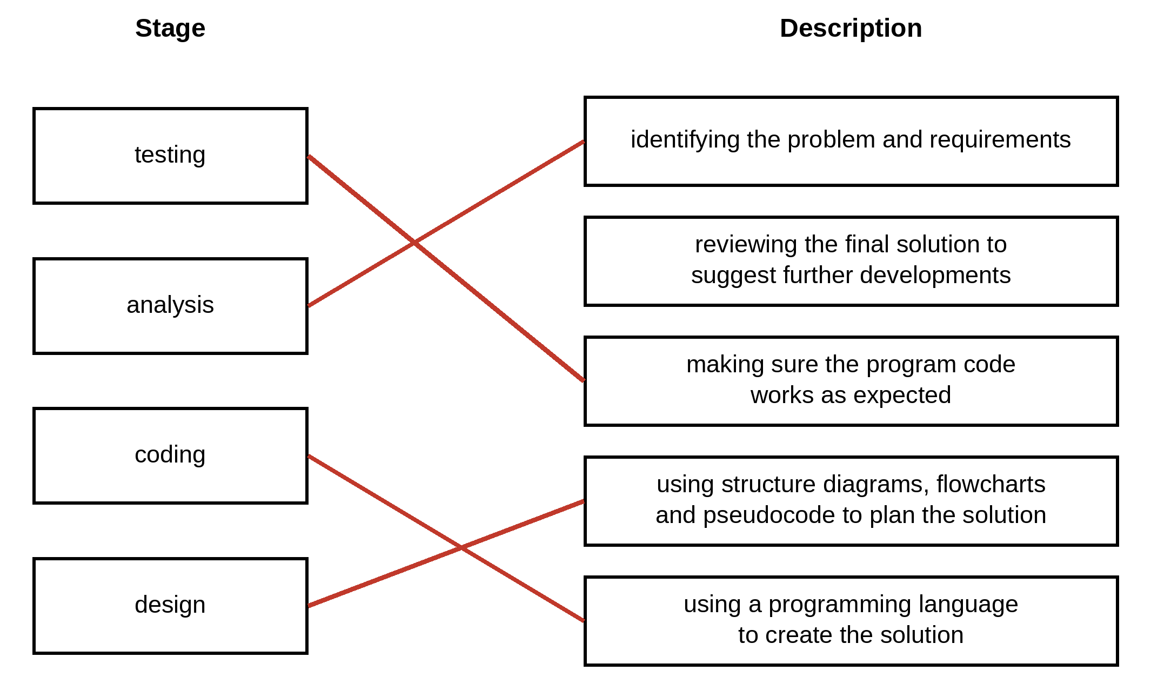
[4]
Marking points
testing → making sure the program code works as expected · analysis → identifying the problem and requirements · coding → using a programming language to create the solution · design → using structure diagrams, flowcharts and pseudocode to plan the solution (one mark each) [4]
10 Identify three different ways that the design of a solution to a problem can be presented.
Source: 0478/22 May/June 2023 Q3
1
2
3 [3]
Marking points
structure diagram / chart · flowchart · pseudocode [3]
11 A food ordering system is an example of a computer system that is made up of sub-systems.
Source: 0478/22 February/March 2023 Q5
The food ordering system:
• allows the user to enter the details of the food they want to order and to pay for the order
• displays food available as pictures or as a list.
Complete the structure diagram for the given parts of the food ordering system.
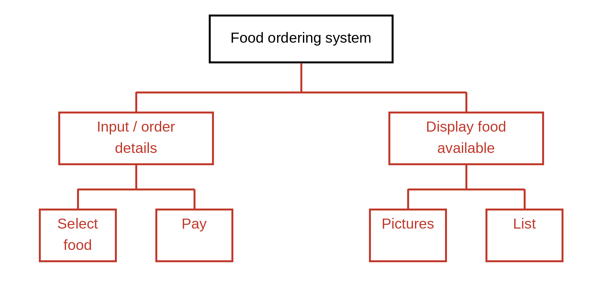
[4]
Marking points
1 mark: suitable hierarchical structure · 1 mark: suitable names for the sub-systems for user input and display · 1 mark: sub-systems for user inputs (food order and payment) · 1 mark: sub-systems for display output types (pictures and list) [4]
12 Four flowchart symbols and five purposes are shown.
Source: 0478/22 October/November 2024 Q3 (symbols redrawn)
(a) Draw one line to link each flowchart symbol to its correct purpose. Not all purposes will be used.
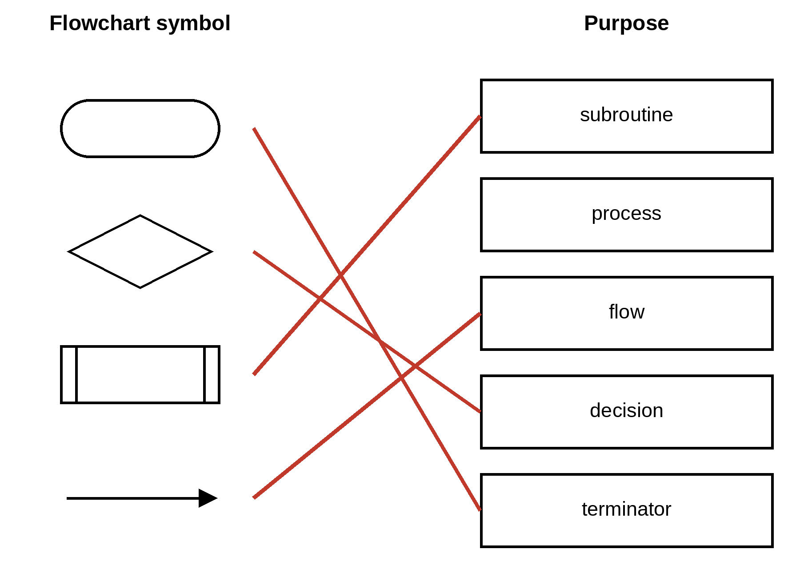
[4]
(b) An algorithm needs to total 50 numbers between 1 and 100 inclusive. Draw a flowchart that:
• uses a count-controlled loop from 1 to 50
• uses an appropriate prompt to ask for a number between 1 and 100
• totals the numbers as they are entered
• outputs the total after the loop has completed with an appropriate message. [6]
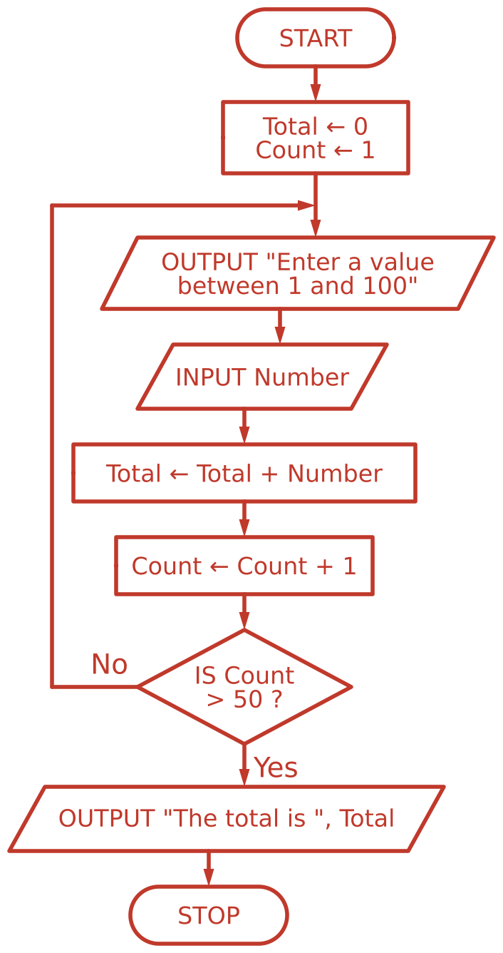
Marking points
(a) terminator · decision · subroutine · flow (one mark each line; process not used) [4]
(b) One mark each: two labelled terminators START and STOP · loop initialisation, incrementation and termination · input with prompt · Total initialised and totalling of inputs · output with message · fully correct flowchart with all arrows, Yes/No labels and correct symbols [6]
13 Tickets for a theme park are booked online. An adult ticket costs $12.99 and a child ticket costs $7.99. A booking fee of $1.99 is added to the total cost of each booking.
Source: 0478/23 October/November 2025 Q4(a)(b)
(a) Write an algorithm in pseudocode to:
• input the number of adult tickets for a booking
• input the number of child tickets for a booking
• calculate and output the total cost of the booking using an appropriate message.
OUTPUT "Please enter the number of adult tickets "
INPUT Adult
OUTPUT "Please enter the number of children "
INPUT Child
Total ← (Adult * 12.99) + (Child * 7.99) + 1.99
OUTPUT "The total cost is ", Total
(b) Each booking must have at least one adult ticket. Explain how the algorithm could be changed to repeatedly ask for the number of adult tickets if the number input is less than 1. Any code used must be fully explained.

[4]
Marking points
(a) One mark each: input of adult and child numbers · calculation of the total of adult and child tickets · … with the booking fee added · output of the total with an appropriate message [4]
(b) One mark each: add a WHILE loop // REPEAT … UNTIL loop · … with the correct condition (Adult < 1 / UNTIL Adult >= 1) · with a suitable (error) message · input of Adult inside the loop [4]
14 The flowchart represents an algorithm.
Source: 0478/21 October/November 2025 Q7
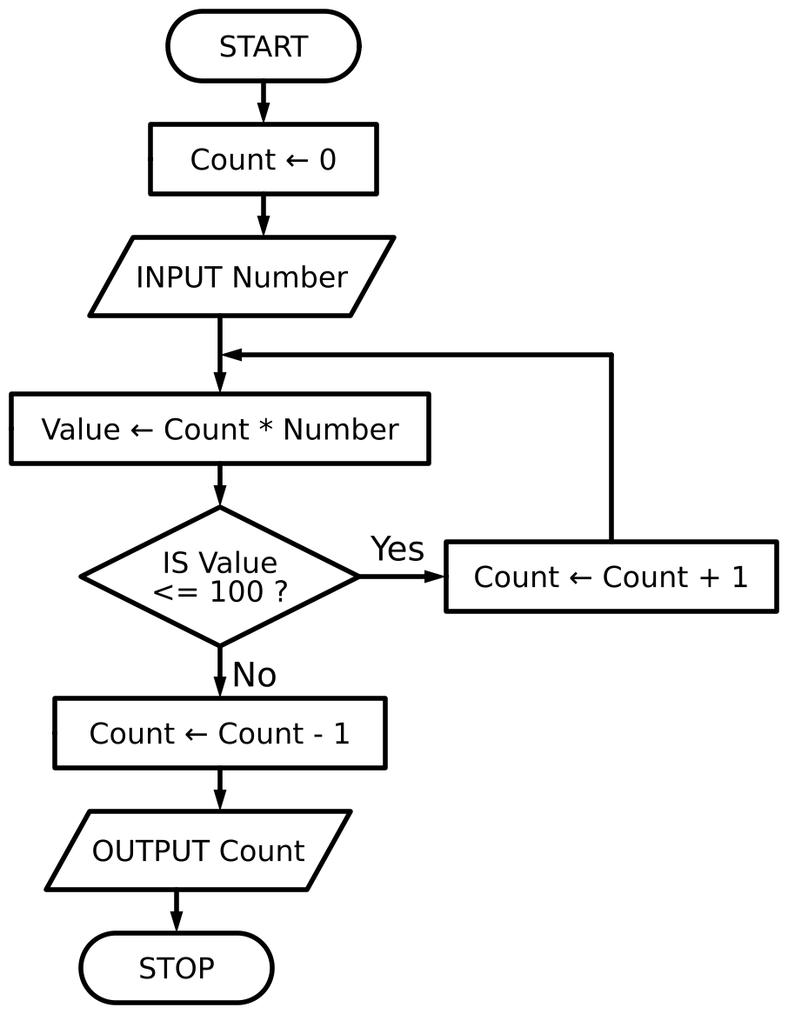
(a) Complete the tables, using the flowchart, for the given data:
Input data: 20
Count | Number | Value | Output
0 | 20 | 0
1 |  | 20
2 |  | 40
3 |  | 60
4 |  | 80
5 |  | 100
6 |  | 120
5 |  |  | 5

Input data: 110 [4]
Count | Number | Value | Output
0 | 110 | 0
1 |  | 110
0 |  |  | 0

(b) State the purpose of the algorithm.

[1]
(c) State a suitable data type for the variable Count.
[1]
(d) Write the algorithm in pseudocode.
DECLARE Count : INTEGER
Count ← 0
INPUT Number
Value ← Count * Number
WHILE Value <= 100 DO
Count ← Count + 1
Value ← Count * Number
ENDWHILE
Count ← Count - 1
OUTPUT Count
Marking points
(a) One mark per column across both tables (Count · Number · Value · Output) [4]
(b) Any one: DIV algorithm // integer division · finds how many times the number goes into 100 [1]
(c) Integer [1]
(d) One mark each: declare Count · use of WHILE / REPEAT loop · … with correct condition · output of correct count — OR — declare Count · initialise Count · use of DIV · … with correct parameters, e.g. Count ← DIV(100, Number) [4]
15 The flowchart represents an algorithm. It uses the one-dimensional (1D) array ClassList.
Source: 0478/23 October/November 2025 Q6(a)(b); part (c) exam-style
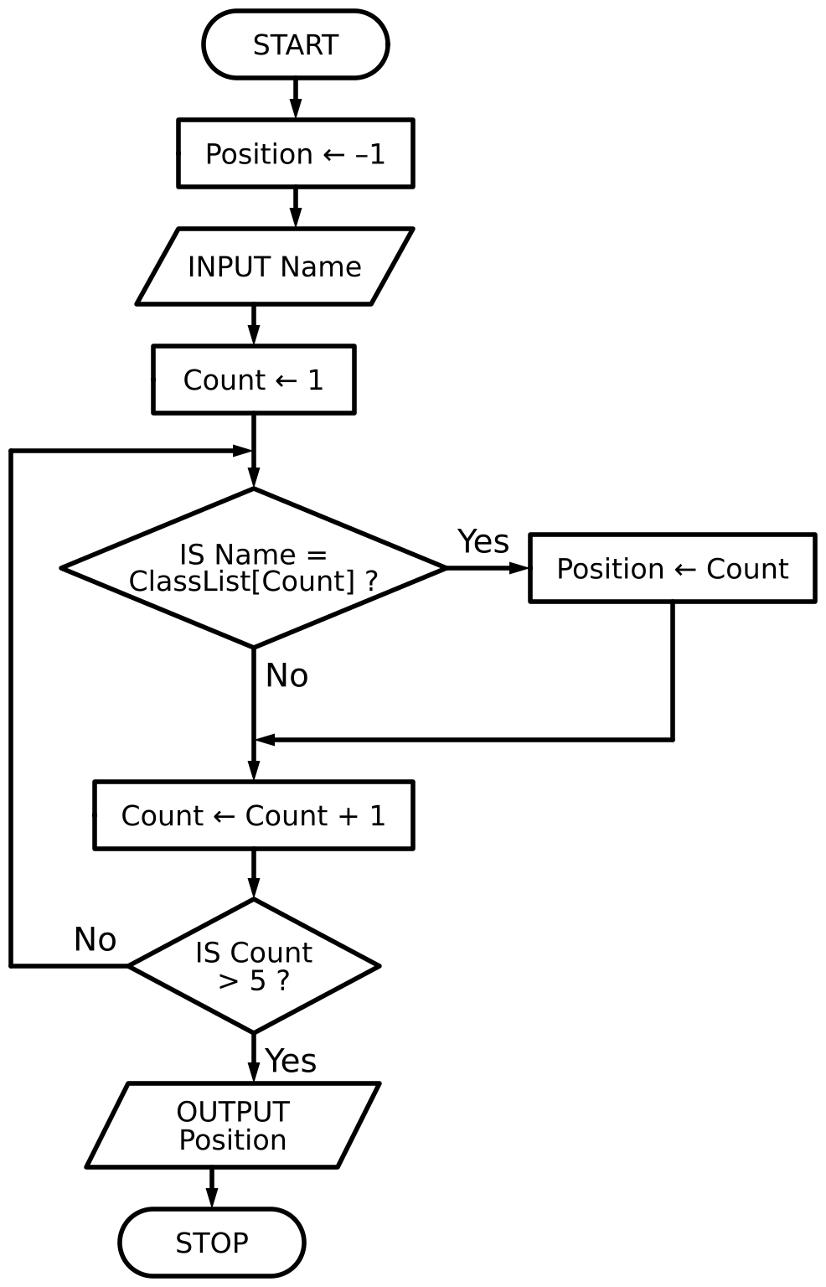
(a) ClassList contains the following data:
Index | 1 | 2 | 3 | 4 | 5
ClassList | Henil | Sven | Ella | Asia | Ridwan

Complete the table by writing the output from the flowchart when each of the given names is input.
Name | OUTPUT
Ridwan | 5
Yan | –1
Ella | 3

[2]
(b) Identify the standard method of solution used by the flowchart.
[1]
(c) Write pseudocode to declare the array ClassList and to store the five names shown in part (a).
DECLARE ClassList : ARRAY[1:5] OF STRING
ClassList[1] ← "Henil"
ClassList[2] ← "Sven"
ClassList[3] ← "Ella"
ClassList[4] ← "Asia"
ClassList[5] ← "Ridwan"
Marking points
(a) Ridwan 5 · Yan –1 · Ella 3 (1 mark for two correct rows, 2 marks for three) [2]
(b) (Linear) search [1]
(c) Exam-style, written for this paper. One mark each: DECLARE ClassList : ARRAY[1:5] … · … OF STRING · all five names stored in the correct elements (accept a FOR loop with INPUT ClassList[Index]) [3]

END OF PAPER

